**A brief history of Agile software development**

In the 1990s, [software development faced a bit of a crisis](https://techbeacon.com/app-dev-testing/agility-beyond-history-legacy-agile-development). Referred to as ‘the application development crisis’ or ‘application delivery lag’, the industry realized that it couldn’t move fast enough to meet customer demands and requirements — the estimated time between a business need and actual application was about three years. See, traditional development models were based on a timeline approach, where development happened sequentially and the final product wasn’t revealed to customers until the very final step. This left little room for flexibility when it came to progress reviews and changes. So, by the time an actual application was finished, it was highly likely that requirements and systems of the project’s original objectives had changed.

With money and efforts wasted, and even some projects cancelled halfway through, professional leaders of the software community thought it was time for a new, refreshed approach. Then in 2001, in a snowy, ski lodge in Utah, gathered 17 individuals. Some of whom were already entertaining the idea of a new software development method. They all yearned to cement a process that legitimized what was being practiced, and so, came the creation of the Agile Manifesto.

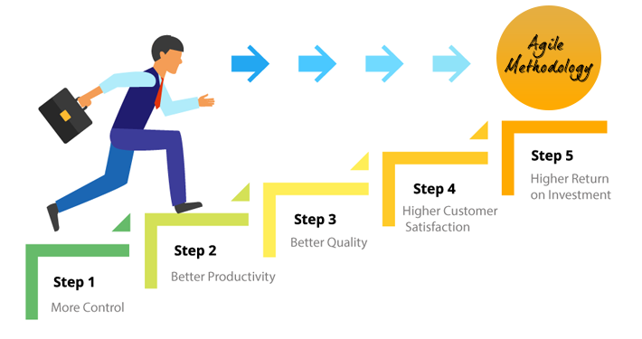

What is the Agile Manifesto?

The [Agile Manifesto](https://zenkit.com/en/blog/uncovering-the-agile-manifesto/) is a declaration of the values and principles expressed in Agile methodology. Made up for four foundational values and 12 key principles, it aims to help uncover better ways of developing software by providing a clear and measurable structure that promotes iterative development, [team collaboration](https://zenkit.com/en/blog/10-must-haves-for-successful-team-collaboration/), and change recognition.

The values and principles of the ‘[Manifesto for Agile Software Development](http://agilemanifesto.org/)’ are:

What is Agile project management?

[Agile project management](https://zenkit.com/en/blog/agile-project-management-a-beginners-guide/) is a methodology that is commonly used to deliver complex projects due to its adaptiveness. It emphasizes collaboration, flexibility, continuous improvement, and high quality results. It aims to be clear and measurable by using six main “deliverables” to track progress and create the product.

**Agile Scrum methodology**

[Scrum](https://zenkit.com/en/blog/scrum-101-an-introduction-to-scrum-project-management/) is an Agile framework that is used to implement the ideas behind Agile software development. Created by [Jeff Sutherland and Ken Schwaber](https://www.scrumguides.org/) (who were also part of the 17 individuals who cemented the Agile Manifesto), it’s comprised of [five values](https://scrumguides.org/scrum-guide.html#values): commitment, courage, focus, openness, and respect. Its goal is to develop, deliver, and sustain complex products through collaboration, accountability, and iterative progress.